

**BUSINESS PROPOSAL**

Ammar Khan 17010020010

Song Young Woong 1701002008

|  |  |
| --- | --- |
| Executive Summary | 3 |
| Company Overview | 4 |
| Product Description | 5 |
| Market Analysis | 8 |
| Operating Plan | 12 |
| Marketing and Sales Plans | 12 |
| Financial Plans | 13 |
| Project Capability | 14 |
| References | 15 |

**Table of Contents**

EXECUTIVE SUMMARY

Book Hive is a merger of two concepts of two technologies of digital era that is to deliver Digital E-Books around the globe via internet without buying each book individually. It maintains a rich source of books for students of different disciplines and for general audience and a smart, sleek, reliable delivery method for these books wherever you go. It eliminates the hurdles to carry your text books and there is no need to buy them individually or you don’t have to go to libraries. You can utilize this system via your smartphone, tablet or a computer with an active internet connection. While being sole contender in the digital market, Book hive ensures reliability and easy access to its customers on monthly subscription basis. The business requires low finances to kick start and nearly no maintenance. It is a project designed to be kick started keeping the financial condition of an average student.

* **Opportunity:** Book Hive is going to solve the problem of providing books everywhere you go. You don’t need to buy every single book, neither to carry them.
* **Mission:** To provide books of almost broad spectrum to students, book lovers hobbyists without a need to buy individual book.
* **Your Solution:** The era of digitalization where we live in a world deeply concentrated with smart phones and a strong internet (wireless and wired) backbone, we aim to provide books everywhere you go. Books are expensive to buy and hard of carry and becomes only a collectible once you have read it. To avoid these hurdles and save paper waste, this one stop solution aims to provide vast variety of books by affordable monthly subscription.
* **Market Focus:** Students who can’t buy expensive original books plus carrying all the course books is a huge burden. Secondly, to those who likes to read books for general knowledge but find it hard to take them everywhere. Thirdly, to those who are struggling to find quality books in the libraries and the environment isn’t suitable for them.
* **Expected Returns:** Book Hive is going to provide subscriptions on monthly basis while keeping in mind that there is no other competitor in the market, but the charges are going to be on minimum profit return policy as it is mostly focused on spreading knowledge effectively in the digital era.

COMPANY OVERVIEW

Book Hive is currently the sole marketer of book suppling on subscription basis in the whole world. The idea is to provide books everywhere and to anyone with minimum profit, that is to spread knowledge using the techno boom in the world. Low business setup cost and high motivations and broader vision is what that fuels this startup. Initially, the setup comprises of a single computer engineer to deploy the setup and a book lover who constantly keeps an eye on the book market.

* **Company Summary:** Book Hive is the sole market contender even in this stage of wide spread usage of technology. The team is focused to deliver the books by tackling any hurdles and puzzles for its customers. Company accompanies latest equipment and large bandwidth along with qualified technical team to ensure fast and reliable delivery of books around the globe.
* **Mission Statement:** Book Hive is going to benefit education sector immensely due to its easy going interface providing tons of books at your mobiles/computers etc everywhere you go.
* **Company History:** Book Hive came into existence using logic of “Doctrine of Necessity”. We all face these hurdles in our daily life and main purpose of Book Hive is intended to address this major issue.
* **Markets and Products:** The immediate market that Book Hive aims to expand are the students who have to suffer the lack of good books in the libraries and low budget to buy them individually. Moreover, next target audience is the mature audience who strive for general knowledge but finds it hard to get them. Book Hive, with its online delivery method of viewing books with monthly charges.
* **Management Team:** Book Hive is currently deployed and managed by two persons who shares love for books and are technically sound in the field of data deploying via cloud.
* **Legal Structure and Ownership:** Book Hive is currently owned by two Co-Founders Ammar Khan and Song Young Wong on partnership basis.
* **Locations and Facilities:** Book Hive is currently deployed on powerful server computer running in the Co-Founder’s personal home. As the startup expands, we plan on moving into a powerful server farm.

PRODUCT DESCRIPTION

Book Hive is likely to expand because the problem addressed is also grave and unaddressed. Being a sole business with such a vision in the market is also a risk, but it requires minimum resources to which avoids the threat of financial bankruptcy. With its broad spectrum of books and reliable deployment and easy viewing method, customers will be charged $10 monthly. Book Hive also incorporates discounts and grants to those who can’t pay up this amount. The aim is to make the knowledge a widespread phenomenon eliminating the need of buying every single book for each individual.

* **Opportunity:** Book Hive is the sole contender in the market. So, sky is the limit and we are going to define the standards for the future relevant market of this type by ensuring quality and quantity.
* **Product Overview:** The service we are going to provide is going to target education sector by providing course and reference books on minimum cost monthly. Book lovers are going to enjoy rich collection of books. All of these services are going to be provided via the internet.
* **User Interface**:



Main Screen

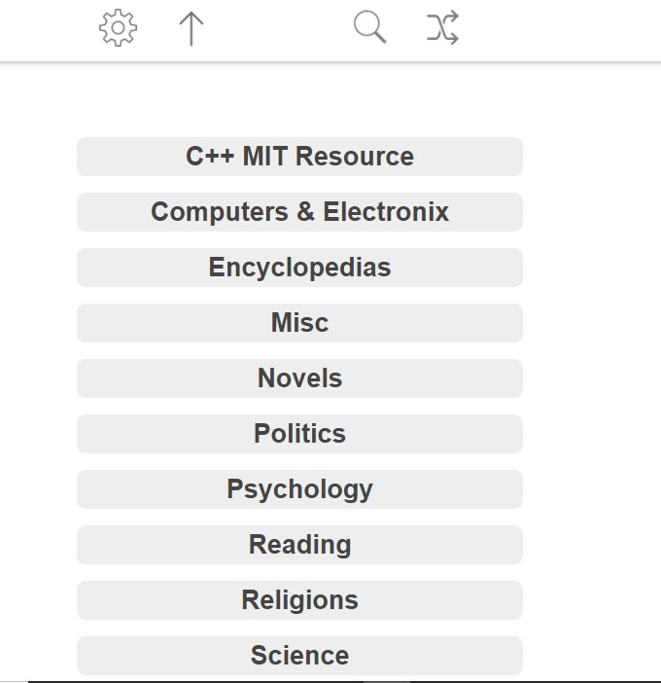

Category Screen

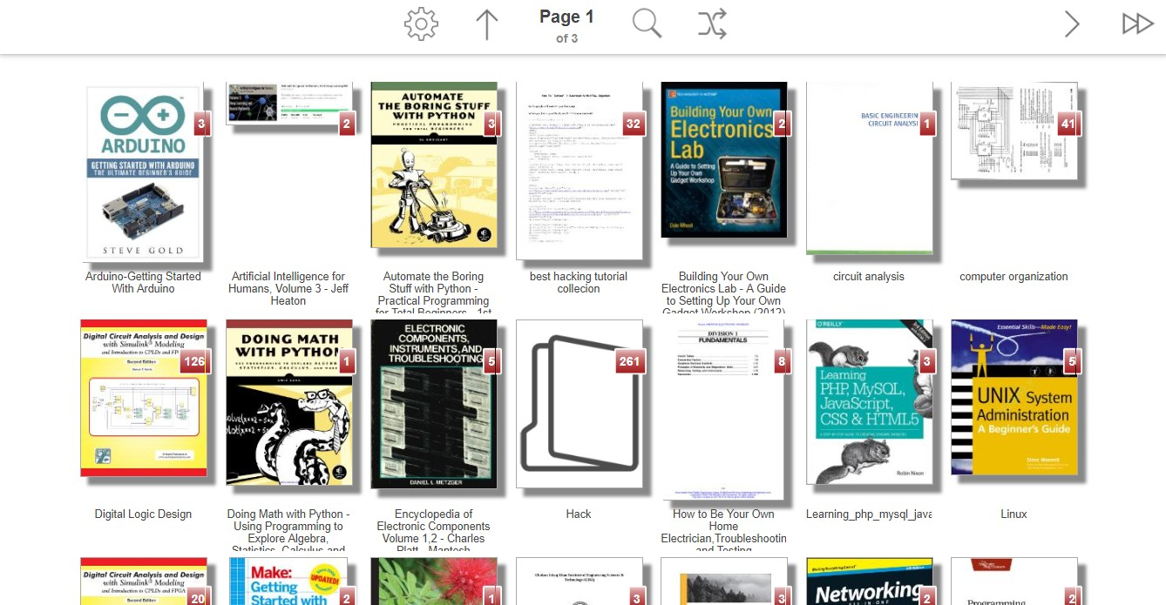

Book Selection screen

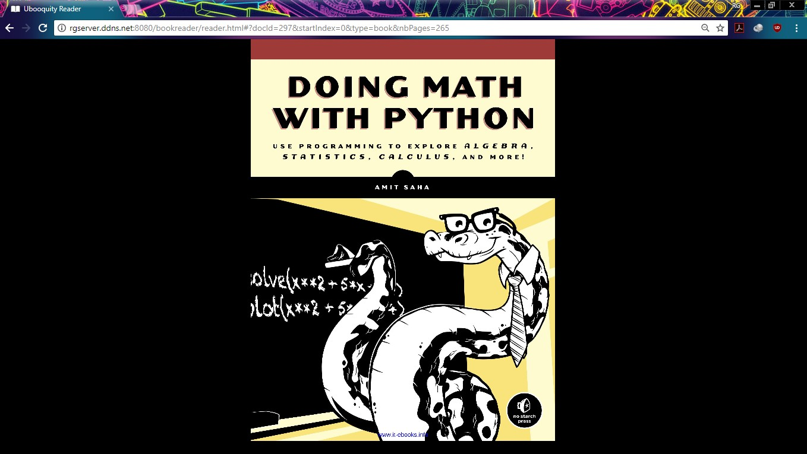

Book Reading Screen

* **Pricing:** Book Hive is will charge $10 for its monthly subscription per individual. Discounts and grants are also available on financial need base.

MARKET ANALYSIS

* The revenue from the global book publishing market is forecast to slightly increase in the coming years, growing from around 113 billion U.S. dollars in 2015 to about 123 billion U.S. dollars by 2020. British company Pearson is the [largest publishing house](https://www.statista.com/statistics/279381/revenue-of-the-largest-publishers-worldwide/) in the world as of 2015. Besides Pearson, Thomson Reuters, RELX Group, Wolters Kluwer and Penguin Random House are also leading book publishers in the world. The U.S. has by far the largest [publishing industry](https://www.statista.com/statistics/248305/publishing-market-value-in-selected-countries-worldwide/), followed by China and Germany.
* Projections for the [book publishing industry in the U.S.](https://www.statista.com/statistics/560733/book-publishing-revenue-usa/) are optimistic. Revenue from this industry in the U.S. is projected to reach to nearly 44 billion U.S. dollars in 2020, a significant increase from 2016. About 2.7 billion [books were sold in the U.S.](https://www.statista.com/statistics/240088/total-book-sales-of-the-us-book-market-by-quantity/) in 2015, a figure that has remained fairly consistent in the last few years. “Harry Potter and the Cursed Child” by J.K. Rowling was the [best-selling print book in the U.S.](https://www.statista.com/statistics/422679/print-book-bestsellers-usa-by-unit-sales/) in 2016, with nearly 4.13 million copies sold that year. Other bestselling print books that year include “The Girl on the Train” by Paula Hawkins and “A Man Called Ove” by Fredrik Backman.   
    
  E-books have been gaining pace in the book industry in the U.S. About 73 percent of publishers and authors had published their [books digitally in the U.S.](https://www.statista.com/statistics/317849/digital-publishing-usa/) in 2015, and nearly 80 percent stated planning to publish e-books in 2016. Despite the rising popularity of e-books in the U.S. among publishers, forecasts show that the number of [e-books readers](https://www.statista.com/statistics/455743/digital-publishing-product-format-users-digital-market-outlook-usa/) is expected to slightly drop in the coming years. In 2015, there were 92.64 million people reading e-books in the country. By 2021, this figure is projected to drop to 88.45 million. [Popular devices](https://www.statista.com/statistics/707678/considering-e-reading-device-brands-or-products/) used to read e-books in the U.S. include Amazon’s Kindle, Barnes & Noble’s Nook, and Kobo.   
    
  Audiobooks, which first gained popularity in the consumer market in the cassette tape and CD era, are back in the digital media era. The number of [audiobook published in the U.S.](https://www.statista.com/statistics/261185/number-of-audiobooks-published-in-the-us/) increased dramatically in the last few years, going from about 7,200 published titles in 2011 to more than 35,500 published titles in 2015. Self-help/spirituality audiobooks are particularly popular in the U.S., as 35 percent of audiobook listeners in the U.S. stated preferring this [audiobook genre](https://www.statista.com/statistics/249846/preferred-audiobook-genres-in-the-us/).   
    
  Despite of the rise of digital book formats, printed books still have their space in the market. [Unit sales of printed books in the U.S.](https://www.statista.com/statistics/422595/print-book-sales-usa/) saw a decline from 2008 until 2012, reaching the lowest figure of the last decade that year. After 2012, sales of printed books started to gain momentum, and have slightly increased up until 2015. Sales figures aside, printed books are still the preferred format of 65 percent of [book readers in the U.S.](https://www.statista.com/statistics/222754/book-format-used-by-readers-in-the-us/)  
    
  About 73 percent of book readers in the U.S. said they read books in any format. The average American aged 18 to 49 reads 12 books per year, while the [average number of books read](https://www.statista.com/statistics/222743/mean-number-of-books-read-in-the-us/) by 65 or older Americans is slightly higher – a total of 13 books per year. Some 23 percent of respondents in a 2017 survey stated that they read [print books and e-books equally](https://www.statista.com/statistics/703357/consumers-preference-for-print-books-or-e-books/), while 20 percent said that they read more e-books. Mystery, thriller and crime genre is the [leading book genre in the U.S.](https://www.statista.com/statistics/201404/types-of-books-that-american-adults-read/), as nearly half of American consumers prefer this genre. About 33 percent of them stated history was their favorite book genre and 31 percent Americans said biographies and memoir was their preferred type of book.
* **Industry Type:** The technology has already replaced conventional book printing method by a large factor but has failed to provide it with the latest standards of Cloud Computing deployment. Book Hive is going to be a bleeding edge technology to make the current technology incorporated obsolete.

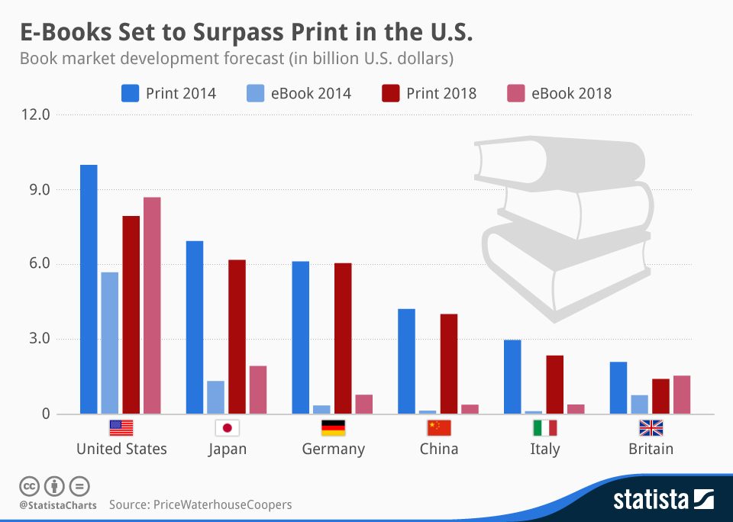

* **Market Segmentation and Competition:** Book Hive is going to be pitch against the company doing relevant business with obsolete technology. Hence our main competition would be to attract as much customers from these corporate giants by providing cutting edge technology and easy going facilities.

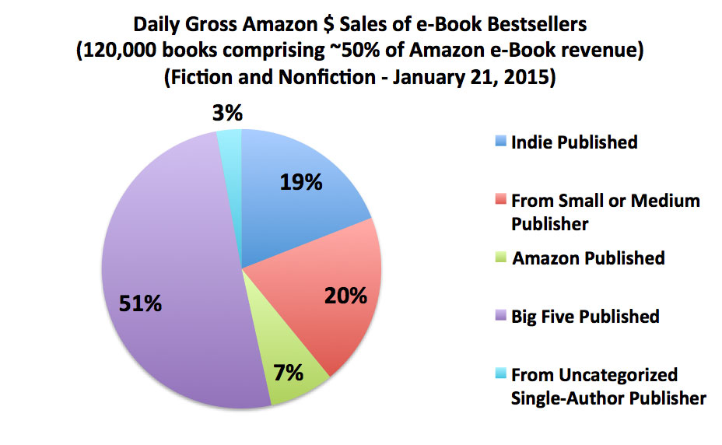

Since, our Initial plan is not country specific because these are the challenges faced by everyone in the world who wants to tackle these problem. Our reliable delivery method will make this project accessible worldwide.

OPERATING PLAN

Book Hive initially requires a full fledge server grade computer machine along with redundant internet connections capable of handling large bandwidth requirements. The setups accompanies open source software from Ubooquity along with adjustments and load balancing and servicing infrastructure techniques guided and provided by Co-Founders. The system contains self-sustainability and protection from DDOS attacks. So no staffing is required initially. However with the success of project, systems are to be deployed over a large scale and organization growth plan will be provided then according to the need.

* **Payment:** Customers can pay for their monthly subscriptions via Easy-Paisa and PayPal which will cover both Pakistan and Global Scope.

MARKETING AND SALES PLAN

Book Hive at its first stage is going to target students in various universities of Pakistan via seminars. Foreign universities are going to be targeted via Webinars. To propagate the concept of education everywhere, our team is dedicated to create as much content as they can and launch various campaigns online to ensure that Book Hive’s motto is heard.

* **Key Messages:** The motto of Book Hive is “You can learn anything anywhere”.
* **Sales Strategy:** Sales strategy accompanied is the Book Hive own reason for birth that is latest technology. Monthly subscription procedure is accompanied keeping in view that it is hard for students to pay one time a hefty amount.

FINANCIAL PLAN

Book Hive is planned in such a way that it could afford and carry even with the finances of a student.

**One time cost:**

* Synology DS218j Network Storage DiskStation $169
* Two RAID-1 4 TB drives $185

That is $380.

**Monthly cost:**

* Two redundant 20Mb/sec internet connections by PTCL $60/month
* Static IP charges $4/month

That is $64/month.

Book Hive already have a large collection of books owned by the Co-Founders which would be utilized for the purpose.

Since the software accompanied is open source and mostly modified and managed by the company itself, so it doesn’t costs anything.

**Cost Balancing:** At least 7 subscribers are required to run the business in no profit/loss situation.

**Investment recovery:** With average 20 subscribers monthly (estimating minimum), the business investment is intended to be recovered in 2 months.

Project Capability

With minimum startup requirements, the hardware can handle immense stress from the subscribers and capable of maintaining its quality service. Graphs below shows the capability of the system that it is able to handle.

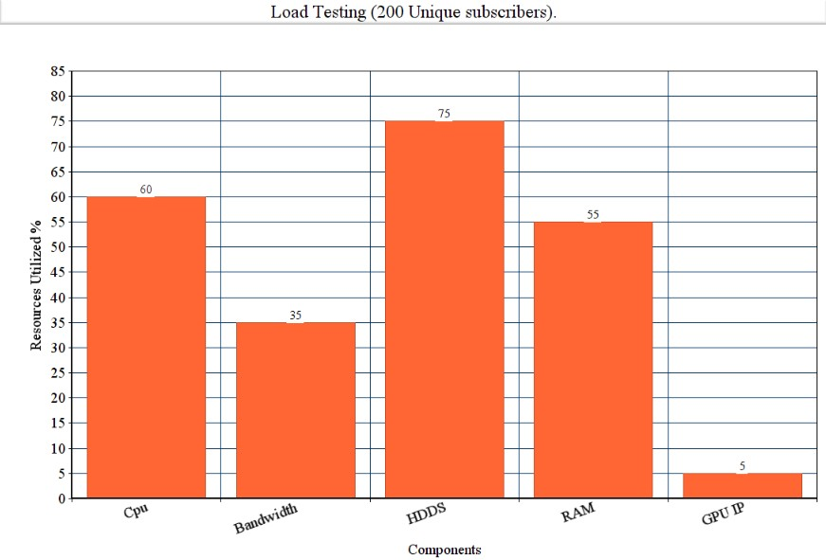

References

* [www.statista.com/topics/1177/book-market/](http://www.statista.com/topics/1177/book-market/)
* [www.statista.com/markets/417/topic/477/books-publishing/](http://www.statista.com/markets/417/topic/477/books-publishing/)
* [www.internationalpublishers.org/market-insights/data-and-statistics](http://www.internationalpublishers.org/market-insights/data-and-statistics)